**CS 2510**

LAST NAME __________________FIRST NAME ____________

**Homework 6**

**PROBLEM 1** [points: 10]

Many garage doors have remote-access keypads outside the door. Let's suppose a thief approaches a particular garage and notices that four particular numbers are well-used. If we assume the code uses all four numbers exactly once, how many 4-digit codes does the thief have to try?

4*3*2*1 = 24 different codes.

What would be your answer if we don’t assume that four numbers could be used exactly once, but instead assume that they could be re-used multiple times?

4*4*4*4 = 256 different codes.

**PROBLEM 2** [points: 10]

Suppose you're given a list of 50 gelato flavors and asked to rank your top 3. How many possible "top 3" lists could be there in total for a person to have?

* If person doesn’t specify the order, just gives 3 “favorite” flavors?

48*49*50/(3*2*1) = 19600 different ways.

* If person specifies which flavor exactly is her/his #1,#2,#3?

48*49*50 = 117600 different ways.

**PROBLEM 3** [points: 10]

If a Martian has an infinite number of red, blue, yellow, and black socks in a drawer, how many socks must the Martian pull out of the drawer to guarantee it has a pair?

(Note: pair means two socks of the same color, so Martian wouldn’t embarrass itself at a Martian convention that day).

There are 4 different colors of socks available. So, n = 4. The Martian will need to pull out n+1, or 5 socks to ensure there is a pair.

**PROBLEM 4** [points: 15]

Let’s assume that no person has more than 1,000,000 hairs on the head, and that the population of New York City was 8,008,277 in 2016.

What is the maximum number of people in NYC for which you can guarantee that they have the same number of hairs on their heads? Explain in detail your solution.

There are 1000001 total number of hairs on heads in New York City. We have 8008277 people in New York. There would be ceil(8008277/1000001) = 9 people with the same hairs on heads.

**PROBLEM 5** [points: 10]

How many distinct permutations can be made from the characters in the word   
**hemidemisemiquaver** (just so you know the definition, it’s the musical timing of 1/64)?

Total permutations = (# of letters)!/((number of each letter)!)

There is 1 h, 4 e, 3 m, 3 i, 1 d, 1 s, 1 q, 1 u, 1 a, 1 v, 1 r

Total permutations = 18!/(1! * 4! * 3! * 3! * 1! * 1! * 1! * 1! * 1! * 1! * 1!) = 7410154752000 distinct permutations.

**PROBLEM 6** [points: 15]

How many ways are there to select 12 countries in the United Nations to serve on a council if 5 are selected from a block of 45, 4 are selected from a block of 57, and the others are selected from the remaining 69 countries? Explain your solution.

Let x = Select first 5 countries: 45 choose 5 = 1221759 ways.

Let y = Select next 4 countries: 57 choose 4 = 395010 ways.

Let z = Select last 3 countries: 69 choose 3 = 52394 ways.

I have the total number of ways of picking individual countries from different groups. I will need to use the product rule to find the total number of ways to pick all countries.

#of ways =

x*y*z = 25285712341580460 total ways (calculated by powershell)

**PROBLEM 7** [points: 20]

The deck of cards has 36 cards of 4 suits (clubs ♣, diamonds , hearts ♥ and spades ♠) and 9 denominations (6, 7, .., king K, ace A), like one below (European style).

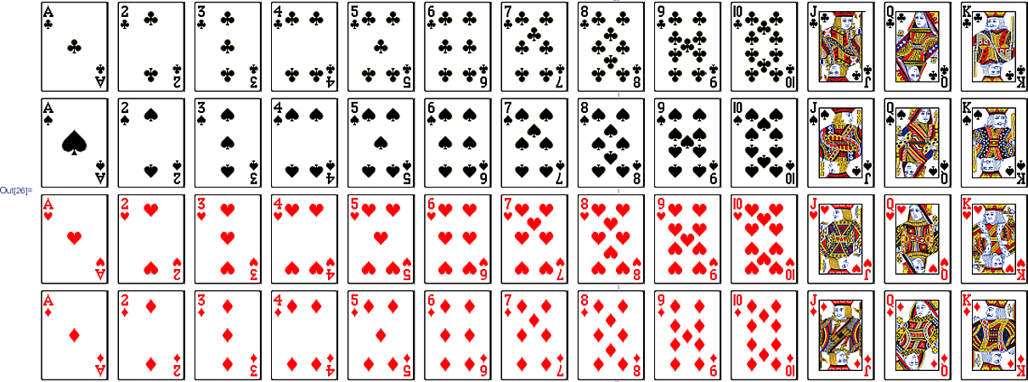

* How many ways to select a hand of 4 cards out of such deck? [points: 3]

There are “36 choose 4” or 58905 ways of choosing 4 cards out of 36.

* How many ways to select a hand of 4 cards so that exactly two are queens?   
  [points: 7]

There are 4 queens, and we need 2. There are 4 choose 2 ways, or 6 total ways of selecting the queens.

Now, we need 2 more cards that are not queens. There are 32 choose 2 ways, or 496 ways to select the last 2 cards.

There is a total of 496*6 = 2976 ways of selecting 4 cards where 2 are queens.

* What is the probability of getting 6 of hearts? 6 of spades? [points: 5]

6 of hearts: There is 1 card of that and 36 total cards, so the probability is 1/36.

6 of spades: There is 1 card of that and 36 total cards, so the probability is 1/36.

* What is the probability of getting a card that is of denomination 6 or 8? [points: 5]

There is a total of 8 cards which have a denomination of 6 or 8. We have 36 cards.

Probability = 8/36 = 2/9

**PROBLEM 8** [points: 10]

A group of seven kids line up in a random order. Each ordering of the kids is equally likely. There are three girls and four boys in the group. What is the probability that all the girls are ahead of all the boys?

There are 7! total ways of arranging the kids. There are exactly 3! * 4! ways where the first 3 spots are occupied by the girls(girls are positioned before the boys).

Probability = (3!*4!)/7! = 1/35